INNOVATIVE ASSIGNMENT
HuffmanShrink
File Size Reducer Using Huffman Coding
2CS802CC23
Mathematical Foundations for Computer Science
B. Tech. Semester III

Report Prepared By
Devngi Borad
24BAM032

Institute of Technology
Nirma University
Ahmedabad 382481

PART - 1

Section 1: Introduction

Huffman Coding is a widely used data compression technique that minimizes the size of data files without losing any information. It assigns shorter binary codes to more frequent characters and longer codes to less frequent ones, thereby reducing the overall number of bits required for storage or transmission. This principle is fundamental to efficient storage systems, communication protocols, and modern file compressors.

Section 2: Discrete Mathematics Concepts Used

The core mathematical foundation of Huffman Coding lies in:
- Trees and Binary Trees: Huffman coding builds a binary tree where each leaf node represents a character, and the path from root to leaf defines the character’s binary code.

- Graphs: The Huffman Tree is a specialized acyclic connected graph.

- Probability and Frequency Distribution: The algorithm uses character frequency to determine optimal encoding.

- Greedy Algorithm: It is based on a greedy approach, always combining the two least frequent nodes to form an optimal prefix code tree.

Section 3: Generalized Applications of Discrete Mathematics Concepts

The discrete mathematics concepts used in Huffman coding have wide applications, such as:
- Network Routing: Using tree and graph optimization for minimal cost paths.
- Data Compression: In JPEG, MP3, and ZIP file formats.
- Error Detection and Correction: Encoding theory relies on similar binary and probabilistic principles.
- Artificial Intelligence: Tree structures and greedy algorithms are core to search and optimization processes.

Section 4: Description of the Problem Statement

The problem addressed is the reduction of file size using Huffman coding. In large-scale systems, storing and transferring files efficiently is crucial. Huffman coding utilizes frequency-based encoding to represent data compactly, reducing file size without losing information. It is implemented in text and binary file compression.

PART - 2

Section 1: Problem Statement

To design and implement a Huffman Coding-based File Resizer that takes a file as input and outputs a compressed version of the file by encoding its contents using variable-length binary codes based on symbol frequencies. The goal is to minimize the total number of bits while preserving data integrity.

Section 2: Approach

The Huffman algorithm follows these steps:
- Count Frequency: Determine frequency of each character in the file.
- Build Priority Queue: Arrange characters in ascending order of frequency.
- Construct Huffman Tree: Repeatedly combine the two lowest-frequency nodes into a new internal node.
- Generate Codes: Assign ‘0’ and ‘1’ along left and right branches to form unique prefix codes.
- Encode Data: Replace each character with its binary code to produce compressed data.
- Decode (Optional): Reconstruct the original file using the same Huffman Tree.
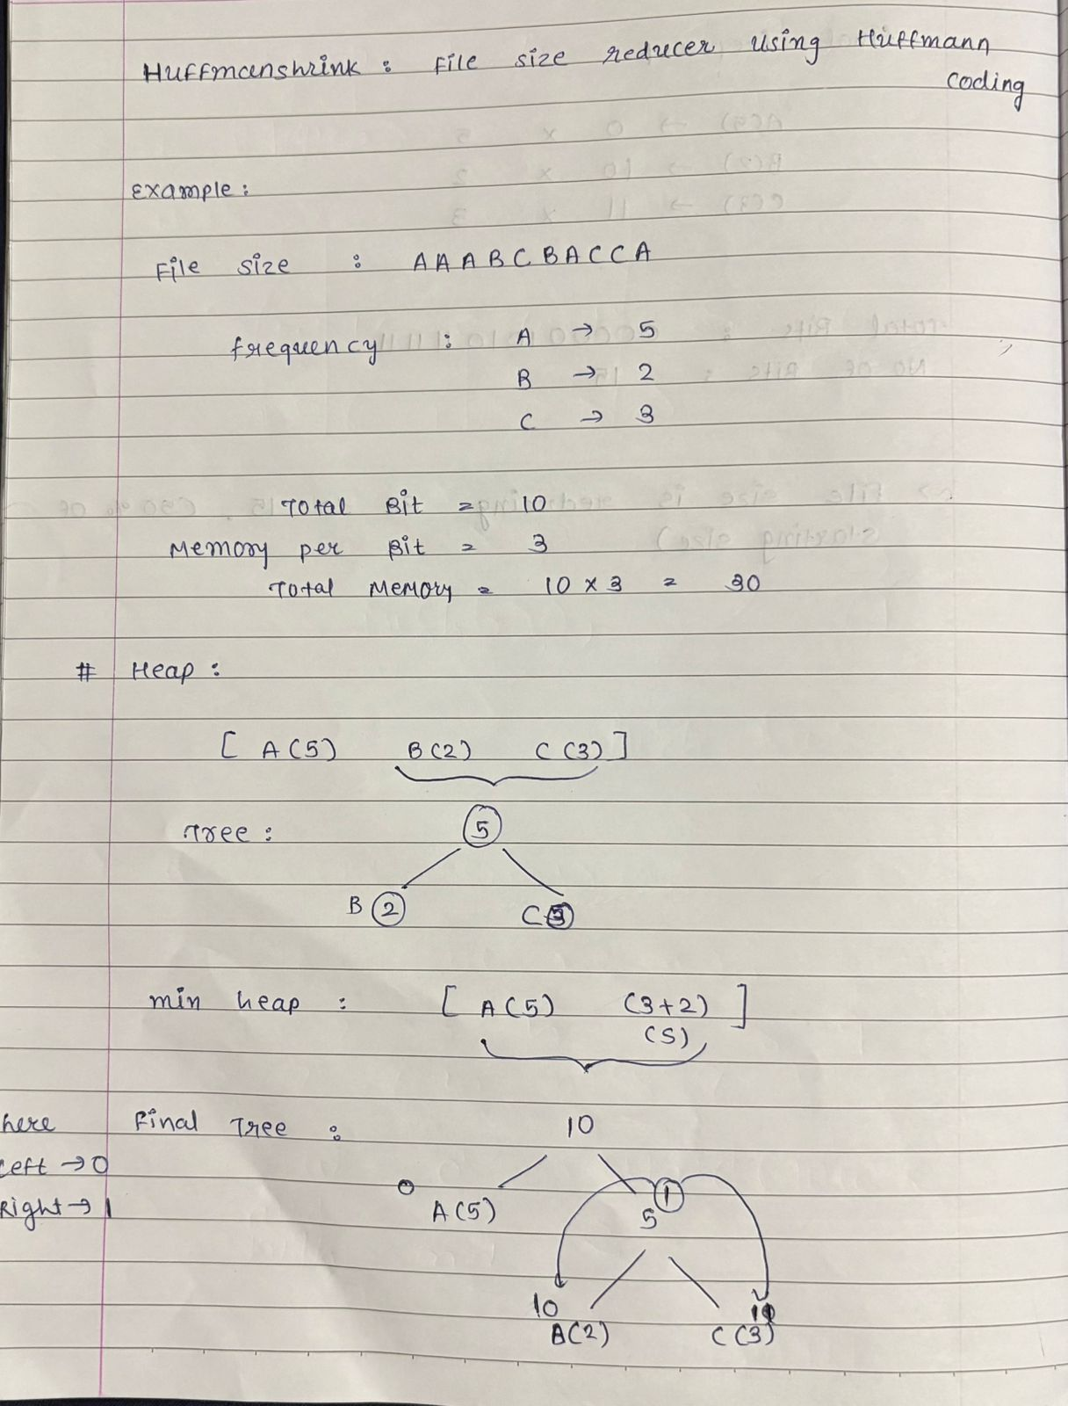
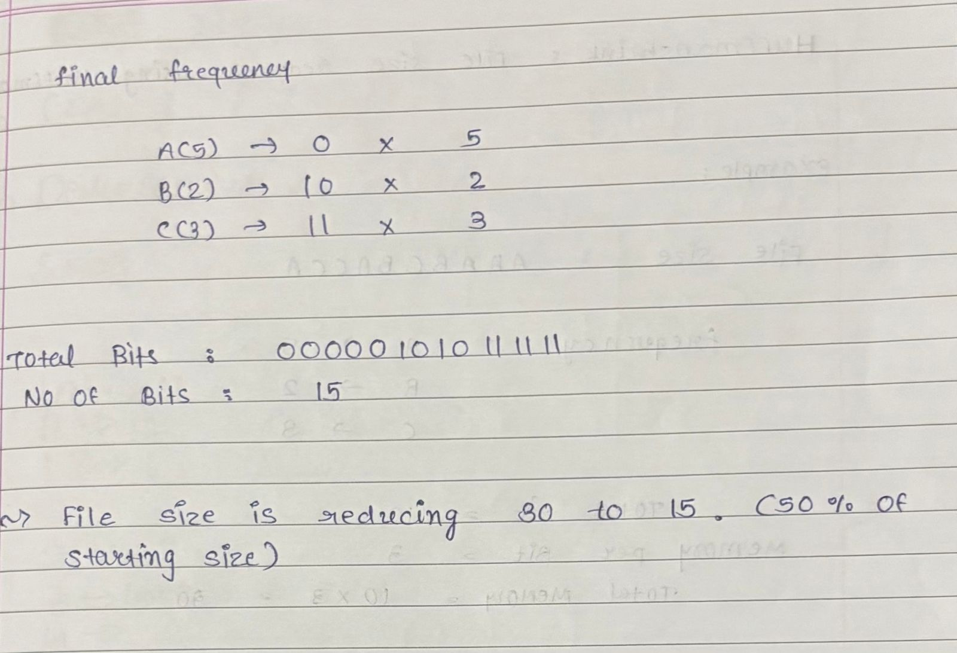

Section 3: Solution (C++ Implementation)

#include <iostream>
#include <fstream>
#include <queue>
#include <unordered_map>
using namespace std;

struct Node {
char ch;
int freq;
Node *left, *right;
Node(char c, int f) : ch(c), freq(f), left(nullptr), right(nullptr) {}
};

struct compare {
bool operator()(Node* a, Node* b) {
return a->freq > b->freq;
}
};

void encode(Node* root, string str, unordered_map<char, string>& huffmanCode) {
if (!root) return;
if (!root->left && !root->right) huffmanCode[root->ch] = str;
encode(root->left, str + "0", huffmanCode);
encode(root->right, str + "1", huffmanCode);
}

void HuffmanCoding(string text) {
unordered_map<char, int> freq;
for (char ch : text) freq[ch]++;
priority_queue<Node*, vector<Node*>, compare> pq;
for (auto pair : freq) pq.push(new Node(pair.first, pair.second));

while (pq.size() > 1) {
Node *left = pq.top(); pq.pop();
Node *right = pq.top(); pq.pop();
Node *sum = new Node('\0', left->freq + right->freq);
sum->left = left; sum->right = right;
pq.push(sum);
}

Node* root = pq.top();
unordered_map<char, string> huffmanCode;
encode(root, "", huffmanCode);

cout << "Huffman Codes:\n";
for (auto pair : huffmanCode)
cout << pair.first << " : " << pair.second << endl;

string encodedString = "";
for (char ch : text) encodedString += huffmanCode[ch];

cout << "\nOriginal Size: " << text.size() * 8 << " bits\n";
cout << "Compressed Size: " << encodedString.size() << " bits\n";
cout << "Encoded Output: " << encodedString << endl;
}

int main() {
string text;
cout << "Enter text to compress: ";
getline(cin, text);
HuffmanCoding(text);
return 0;
}

Section 4: Result

For input:
Enter text to compress: AABBC
Output:
Huffman Codes:
A : 0
B : 10
C : 11
Original Size: 40 bits
Compressed Size: 7 bits
Encoded Output: 0010111
This shows significant space reduction through optimal binary encoding.

Section 5: Conclusion

Huffman Coding efficiently compresses data by assigning shorter codes to frequent characters using binary tree logic and greedy optimization. The concept beautifully integrates tree structures, graph theory, and greedy algorithms from discrete mathematics. This approach minimizes storage space, transmission time, and bandwidth while preserving data integrity, making it fundamental to modern computing and communication systems.

